|  |  |
| --- | --- |
| Bus Communication with Segment Displays.  17rd October 2019.  Prof. Randall Brouwer | Daniel Ackuaku |

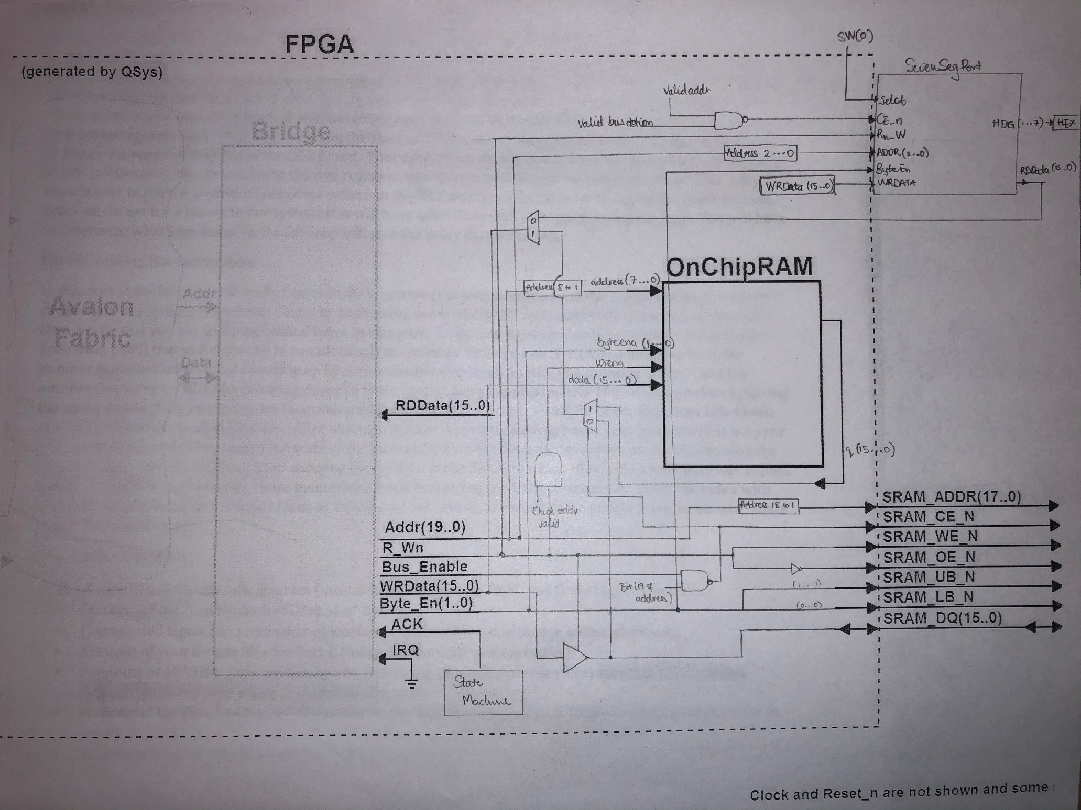

Figure . A block diagram of the SRAM, OnChipRAM and SevenSegPort

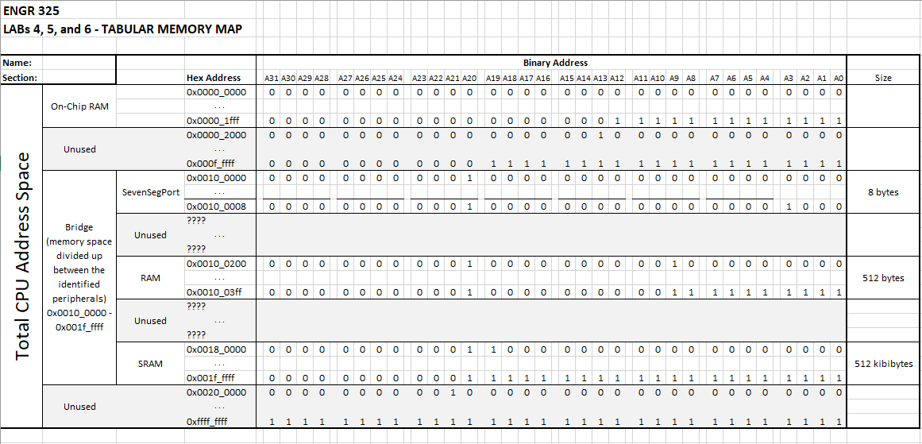

Figure Lab456AddressMap excel file

C CODE for Part E

#include <io.h>

#include "busbridgehal.h"

int main() {

unsigned int SRAMbase; // SRAM base address

unsigned int OnChipRAMbase;

unsigned int mem_point; // memory fill pointer and fill variable

unsigned int mem_fill;

unsigned int SevenSegBase;

OnChipRAMbase = 0x100200;

SevenSegBase = 0x100000;

int sub = 999;

mem_fill=200000;

mem_point=0x00;

while( mem_point <= 512){

writeBusIO(4, OnChipRAMbase, mem_point, mem_fill);

mem_fill = mem_fill-sub;

mem_point += 0x04;

}

SRAMbase = 0x1c0000;

int readPointer = 0x00;

int i = 0;

int read;

while (readPointer < 512){

read = readBusIO(4, OnChipRAMbase, readPointer);

writeBusIO(4, SRAMbase, readPointer, read);

readPointer += 0x04;

}

unsigned int HEXplus3 = 0x0;

unsigned int HEXplus6 = 0x0;

unsigned int HEXplus7 = 0x0;

unsigned int HEXsuba = 0x0;

unsigned int y = 0;

while(1){

writeBusIO(1, SevenSegBase, 0x00, HEXplus3);

writeBusIO(1, SevenSegBase, 0x01, HEXplus6);

writeBusIO(1, SevenSegBase, 0x02, HEXplus7);

writeBusIO(1, SevenSegBase, 0x03, HEXsuba);

HEXplus3 += 0x03;

HEXplus6 += 0x06;

HEXplus7 += 0x07;

HEXsuba -=0x0a;

for (y = 0; y < 5000000 ; y++) {

asm("nop;nop;nop;");

}

}

return 0;

}

VHDL CODE for Lab 6

LIBRARY ieee;

USE ieee.std_logic_1164.ALL;

USE work.SevenSeg_pkg.ALL;

USE ieee.std_logic_unsigned.ALL;

ENTITY Lab6 IS

PORT (

CLOCK_50 : IN STD_LOGIC;

SW : IN STD_LOGIC_VECTOR(0 DOWNTO 0);

KEY : IN STD_LOGIC_VECTOR(0 DOWNTO 0);

SRAM_ADDR : OUT STD_LOGIC_VECTOR(17 DOWNTO 0);

SRAM_DQ : INOUT STD_LOGIC_VECTOR(15 DOWNTO 0);

SRAM_WE_N : OUT STD_LOGIC;

SRAM_OE_N : OUT STD_LOGIC;

SRAM_UB_N : OUT STD_LOGIC;

SRAM_LB_N : OUT STD_LOGIC;

SRAM_CE_N : OUT STD_LOGIC;

HEX0 : OUT STD_LOGIC_VECTOR(6 DOWNTO 0);

HEX1 : OUT STD_LOGIC_VECTOR(6 DOWNTO 0);

HEX2 : OUT STD_LOGIC_VECTOR(6 DOWNTO 0);

HEX3 : OUT STD_LOGIC_VECTOR(6 DOWNTO 0);

HEX4 : OUT STD_LOGIC_VECTOR(6 DOWNTO 0);

HEX5 : OUT STD_LOGIC_VECTOR(6 DOWNTO 0);

HEX6 : OUT STD_LOGIC_VECTOR(6 DOWNTO 0);

HEX7 : OUT STD_LOGIC_VECTOR(6 DOWNTO 0)

);

END Lab6;

ARCHITECTURE Lab6_rtl OF Lab6 IS

-------------------------------------------------------------------------

-- Signal definitions

-------------------------------------------------------------------------

type State_type IS (S1,S2,S3,S4);

signal y_present, y_next : State_type;

Signal ACK_sig : STD_LOGIC;

Signal IRQ_sig : STD_LOGIC;

Signal Bridge_address_sig : STD_LOGIC_VECTOR(19 DOWNTO 0);

Signal Bridge_bus_enable_sig : STD_LOGIC;

Signal Bridge_byte_enable_sig : STD_LOGIC_VECTOR(1 DOWNTO 0);

Signal Bridge_rw_sig : STD_LOGIC;

Signal Bridge_write_data_sig : STD_LOGIC_VECTOR(15 DOWNTO 0);

Signal Bridge_read_data_sig : STD_LOGIC_VECTOR(15 DOWNTO 0);

Signal q_signal : STD_LOGIC_VECTOR(15 DOWNTO 0);

Signal wren_signal : STD_LOGIC;

Signal wren_check : STD_LOGIC;

Signal ChipEn_signal : STD_LOGIC;

Signal ChipEn_check : STD_LOGIC;

Signal RDData_signal : STD_LOGIC_VECTOR(15 DOWNTO 0);

Signal Intermediate_signal : STD_LOGIC_VECTOR(15 DOWNTO 0);

Signal HDig7_signal : STD_LOGIC_VECTOR(3 DOWNTO 0);

Signal HDig6_signal : STD_LOGIC_VECTOR(3 DOWNTO 0);

Signal HDig5_signal : STD_LOGIC_VECTOR(3 DOWNTO 0);

Signal HDig4_signal : STD_LOGIC_VECTOR(3 DOWNTO 0);

Signal HDig3_signal : STD_LOGIC_VECTOR(3 DOWNTO 0);

Signal HDig2_signal : STD_LOGIC_VECTOR(3 DOWNTO 0);

Signal HDig1_signal : STD_LOGIC_VECTOR(3 DOWNTO 0);

Signal HDig0_signal : STD_LOGIC_VECTOR(3 DOWNTO 0);

component nios_system is

port (

clk_clk : in std_logic := 'X'; -- clk

reset_reset_n : in std_logic := 'X'; -- reset_n

bridge_acknowledge : in std_logic := 'X'; -- acknowledge

bridge_irq : in std_logic := 'X'; -- irq

bridge_address : out std_logic_vector(19 downto 0); -- address

bridge_bus_enable : out std_logic; -- bus_enable

bridge_byte_enable : out std_logic_vector(1 downto 0); -- byte_enable

bridge_rw : out std_logic; -- rw

bridge_write_data : out std_logic_vector(15 downto 0); -- write_data

bridge_read_data : in std_logic_vector(15 downto 0) := (others => 'X')

);

end component nios_system;

component OnChipRAM

PORT(

address : IN STD_LOGIC_VECTOR (7 DOWNTO 0);

byteena : IN STD_LOGIC_VECTOR (1 DOWNTO 0) := (OTHERS => '1');

clock : IN STD_LOGIC := '1';

data : IN STD_LOGIC_VECTOR (15 DOWNTO 0);

wren : IN STD_LOGIC ;

q : OUT STD_LOGIC_VECTOR (15 DOWNTO 0)

);

end component;

component SevenSegPort is

Port (

Clock : IN std_logic;

Reset_n : IN std_logic;

Selct : IN std_logic;

CE_n : IN std_logic;

R_Wn : IN std_logic;

ADDR : IN std_logic_vector(2 downto 0);

ByteEn : IN std_logic_vector(1 downto 0);

WRData : IN std_logic_vector(15 downto 0);

RDData : OUT std_logic_vector(15 downto 0);

HDig7 : OUT std_logic_vector(3 downto 0);

HDig6 : OUT std_logic_vector(3 downto 0);

HDig5 : OUT std_logic_vector(3 downto 0);

HDig4 : OUT std_logic_vector(3 downto 0);

HDig3 : OUT std_logic_vector(3 downto 0);

HDig2 : OUT std_logic_vector(3 downto 0);

HDig1 : OUT std_logic_vector(3 downto 0);

HDig0 : OUT std_logic_vector(3 downto 0)

);

end component SevenSegPort;

BEGIN

-------------------------------------------------------------------------

-- Signal assigingments

-------------------------------------------------------------------------

SRAM_ADDR <= Bridge_address_sig(18 downto 1);

SRAM_WE_N <= Bridge_rw_sig;

SRAM_OE_N <= not Bridge_rw_sig;

SRAM_UB_N <= not Bridge_byte_enable_sig(1);

SRAM_LB_N <= not Bridge_byte_enable_sig(0);

SRAM_CE_N <= not (Bridge_bus_enable_sig AND Bridge_address_sig(19)) ;

wren_signal <= ( (NOT Bridge_rw_sig) AND wren_check);

wren_check <= '1' when (Bridge_address_sig(19 downto 9) = "0000000001" AND Bridge_bus_enable_sig = '1') else '0';

-- tri-state buffer for write data -- 19 downto-- 0000000001

SRAM_DQ <= Bridge_write_data_sig when Bridge_rw_sig = '0' else (others =>'Z'); --"ZZZZZZZZZZZZZZZZ";

u0 : component nios_system

port map (

clk_clk => CLOCK_50, -- clk.clk

reset_reset_n => KEY(0), -- reset.reset_n

bridge_acknowledge => ACK_sig, -- bridge.acknowledge

bridge_irq => IRQ_sig, -- .irq

bridge_address => Bridge_address_sig, -- .address

bridge_bus_enable => Bridge_bus_enable_sig, -- .bus_enable

bridge_byte_enable => Bridge_byte_enable_sig, -- .byte_enable

bridge_rw => Bridge_rw_sig, -- .rw

bridge_write_data => Bridge_write_data_sig, -- .write_data

bridge_read_data => Bridge_read_data_sig -- .read_data

);

OnChipRAM_inst : OnChipRAM

PORT MAP (

address => Bridge_address_sig(8 downto 1),

byteena => Bridge_byte_enable_sig,

clock => CLOCK_50,

data => Bridge_write_data_sig,

wren => wren_signal,

q => q_signal

);

SevenSegPort_inst : component SevenSegPort

port map (

Clock => CLOCK_50,

Reset_n => KEY(0),

Selct => SW(0),

CE_n => ChipEn_signal,

R_Wn => Bridge_rw_sig,

ADDR => Bridge_address_sig(2 downto 0),

ByteEn => Bridge_byte_enable_sig,

WRData => Bridge_write_data_sig,

RDData => RDData_signal,

HDig7 => HDig7_signal,

HDig6 => HDig6_signal,

HDig5 => HDig5_signal,

HDig4 => HDig4_signal,

HDig3 => HDig3_signal,

HDig2 => HDig2_signal,

HDig1 => HDig1_signal,

HDig0 => HDig0_signal

);

----------------------------------------------------------------------------

-- MUX for the Read data conditions

-- between the SRAM_DQ and the onChipRam q_signal

----------------------------------------------------------------------------

Intermediate_signal <= SRAM_DQ when (Bridge_bus_enable_sig NAND Bridge_address_sig(19)) = '0' else q_signal;

----------------------------------------------------------------------------

-- MUX2 for the Read data conditions

-- the result of MUX1 and the SevenSegPort RDData_signal

----------------------------------------------------------------------------

Bridge_read_data_sig <= Intermediate_signal when ChipEn_signal = '1' else RDData_signal;

-----------------------------------------------------------------------------

-- State machine process for the acknowledge

-----------------------------------------------------------------------------

process (Bridge_bus_enable_sig, y_present) is

BEGIN

CASE y_present IS

WHEN S1 => --State1

if (Bridge_bus_enable_sig = '1') then

ACK_sig <= '0';

y_next <= S2;

else

ACK_sig <= '0';

y_next <= S1;

end if;

WHEN S2 => --State2

ACK_sig <= '0';

y_next <= S3;

WHEN S3 => --State3

ACK_sig <= '1';

y_next <= S4;

WHEN S4 => --State4

ACK_sig <= '0';

y_next <= S1;

END CASE;

end process;

process (CLOCK_50, KEY(0))

BEGIN

if (KEY(0) = '0') then

y_present <= S1;

elsif (CLOCK_50' EVENT AND CLOCK_50 = '1') then

y_present <= y_next;

end if;

end process;

-----------------------------------------------------------

-- SevenSegPort CE_N_signal definition.

-----------------------------------------------------------

ChipEn_signal <= Bridge_bus_enable_sig NAND ChipEn_check;

ChipEn_check <= '1' when (Bridge_address_sig(19 downto 5) = "0000000000000000" AND Bridge_address_sig(0) = '0') else '0';

------------------------------------------------------------

IRQ_sig <= '0';

------------------------------------------------------------

-- Converting the register vlaues to SevenSeg

-- Hex display digits

------------------------------------------------------------

HEX7 <= convert_to_7seg(HDig7_signal);

HEX6 <= convert_to_7seg(HDig6_signal);

HEX5 <= convert_to_7seg(HDig5_signal);

HEX4 <= convert_to_7seg(HDig4_signal);

HEX3 <= convert_to_7seg(HDig3_signal);

HEX2 <= convert_to_7seg(HDig2_signal);

HEX1 <= convert_to_7seg(HDig1_signal);

HEX0 <= convert_to_7seg(HDig0_signal);

END Lab6_rtl;

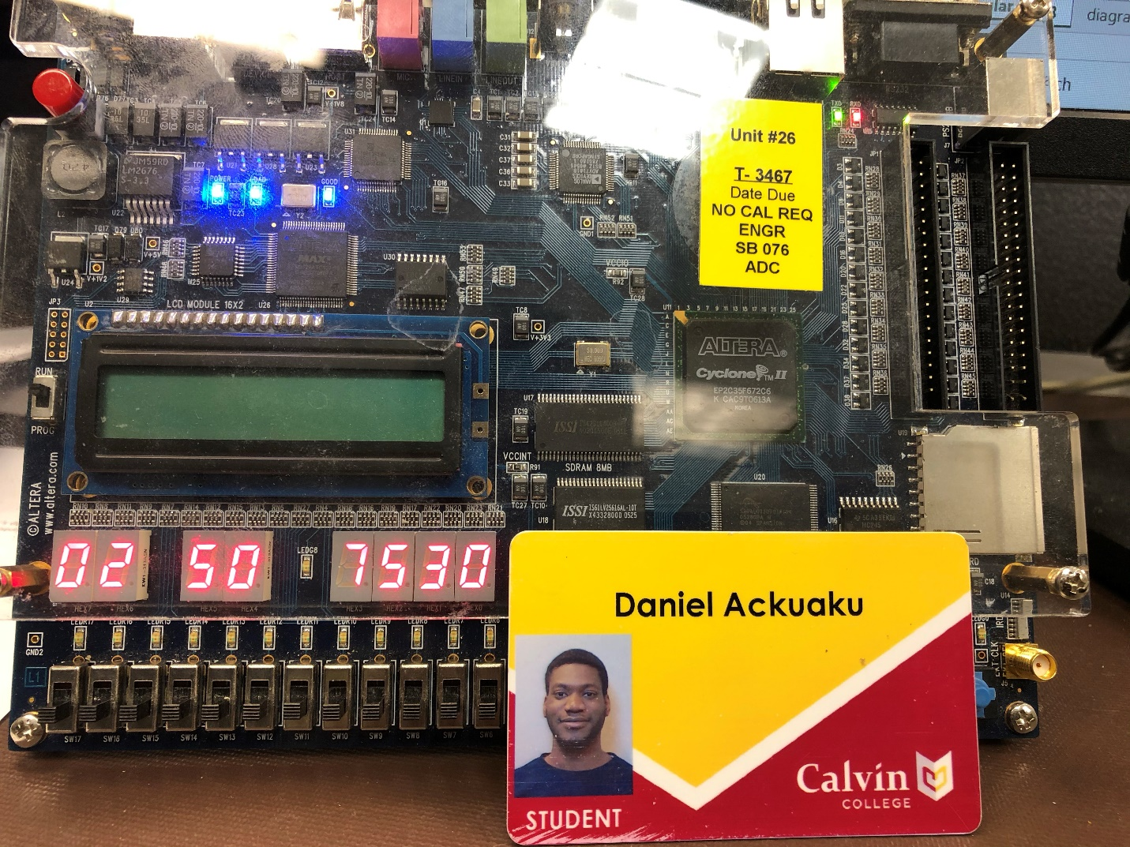

Figure . A photo of my ID and ID num on HEX display.

VHDL Code for SevenSeg

-- Daniel Ackuaku

-- Date: 10/12/2019

Library ieee;

USE ieee.std_logic_1164.all;

-- Explanation of the entity and what it does...

-- (don't make these lines too long to avoid word wrapping)

Entity SevenSegPort is

Port (

Clock : IN std_logic; -- fill in with descriptions of each port

Reset_n : IN std_logic;

Selct : IN std_logic;

CE_n : IN std_logic;

R_Wn : IN std_logic;

ADDR : IN std_logic_vector(2 downto 0);

ByteEn : IN std_logic_vector(1 downto 0);

WRData : IN std_logic_vector(15 downto 0);

RDData : OUT std_logic_vector(15 downto 0);

HDig7 : OUT std_logic_vector(3 downto 0);

HDig6 : OUT std_logic_vector(3 downto 0);

HDig5 : OUT std_logic_vector(3 downto 0);

HDig4 : OUT std_logic_vector(3 downto 0);

HDig3 : OUT std_logic_vector(3 downto 0);

HDig2 : OUT std_logic_vector(3 downto 0);

HDig1 : OUT std_logic_vector(3 downto 0);

HDig0 : OUT std_logic_vector(3 downto 0)

);

End Entity SevenSegPort;

Architecture Display OF SevenSegPort IS

-- This area is used to define types and any internal signals

-- Fill_In as necessary to define signals like "Result", etc

-- Defining the signals for input, output and timing control of the progamme

Signal Register1 : std_logic_vector(31 downto 0); -- input register

Signal Register2 : std_logic_vector(31 downto 0); -- input reigster

Begin

-------------------------------------------------

-- Selct statement for the registers

-------------------------------------------------

Process (Selct, Register1, Register2) is

Begin

Case Selct IS

When '0' =>

HDig7 <= Register1(31 downto 28) ;

HDig6 <= Register1(27 downto 24) ;

HDig5 <= Register1(23 downto 20) ;

HDig4 <= Register1(19 downto 16) ;

HDig3 <= Register1(15 downto 12) ;

HDig2 <= Register1(11 downto 8) ;

HDig1 <= Register1(7 downto 4) ;

HDig0 <= Register1(3 downto 0) ;

When '1' =>

HDig7 <= Register2(31 downto 28) ;

HDig6 <= Register2(27 downto 24) ;

HDig5 <= Register2(23 downto 20) ;

HDig4 <= Register2(19 downto 16) ;

HDig3 <= Register2(15 downto 12) ;

HDig2 <= Register2(11 downto 8) ;

HDig1 <= Register2(7 downto 4) ;

HDig0 <= Register2(3 downto 0) ;

End Case;

End Process;

--CE-N

-----------------------------------------------------------------------------

-- process

-- reading the input into register1

-----------------------------------------------------------------------------

process (Clock, Reset_n) is

begin

if ( Reset_n = '0') then -- if reset is pushed

Register1 <= "00000000000000000000000000000000"; -- set register1 to 0

Register2 <= "00000000000000000000000000000000"; -- set register1 to 0

elsif (Clock'EVENT AND Clock = '1' ) then

if (CE_N = '0' AND R_Wn = '0') then -- when CE_N is asserted low

-- wirte to the lower bits of Register1&2

if (ByteEn(0) = '1')then

if ( ADDR = "000" )then

Register1(7 downto 0) <= WRData(7 downto 0);

elsif ( ADDR = "010" )then

Register1(23 downto 16) <= WRData(7 downto 0);

elsif ( ADDR = "100" )then

Register2(7 downto 0) <= WRData(7 downto 0);

elsif ( ADDR = "110" )then

Register2(23 downto 16) <= WRData(7 downto 0);

end if;

end if;

-- wirte to the upper bits of Register1&2

if (ByteEn(1) = '1')then

if ( ADDR = "000" )then

Register1(15 downto 8) <= WRData(15 downto 8);

elsif ( ADDR = "010" )then

Register1(31 downto 24) <= WRData(15 downto 8);

elsif ( ADDR = "100" )then

Register2(15 downto 8) <= WRData(15 downto 8);

elsif ( ADDR = "110" )then

Register2(31 downto 24) <= WRData(15 downto 8);

end if;

end if;

end if;

end if;

end process;

-- assert read for Register 1 independently of the clock.

RDData(15 downto 0) <= Register1(15 downto 0) when ( R_Wn = '1' AND (ADDR = "000") )else

Register1(31 downto 16) when ( R_Wn = '1' AND (ADDR = "010") ) else

Register2(15 downto 0) when ( R_Wn = '1' AND (ADDR = "100" )) else

Register2(31 downto 16) when ( R_Wn = '1' AND (ADDR = "110")) else (others => '0');

End Display;

